The University of Azad Jammu and Kashmir, Muzaffarabad



Student Name: Adeela Bashir
Class RollNo: 2024-SE-12
Course Title: Database Systems
Submitted To: Engr.Awais Rathore

Department of Software Engineering
Lab#2:
Title: POS Database

Background
For this lab exercise, I designed an e-commerce database using MySQL in XAMPP. The aim was to build a system that organizes users, roles, products, categories, and customer orders in a structured way. I focused on defining relationships between tables to ensure consistency and reduce redundancy.

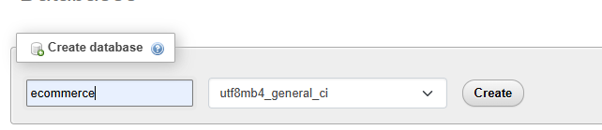

Database Layout

The database, named ecommerce, consists of the following core tables:
- Users
- Category
- Product
- Orders
- Order_Item

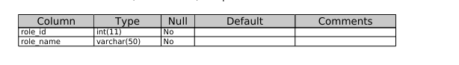
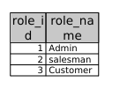
Users Table:
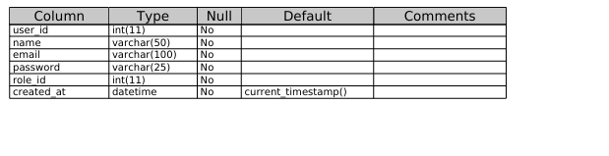
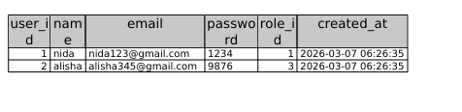
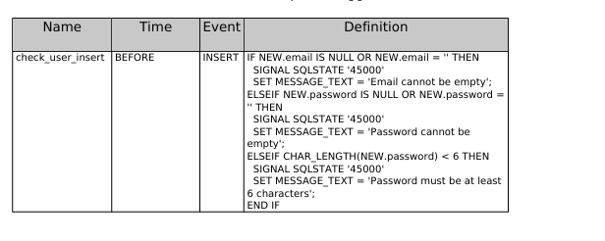
Category Table
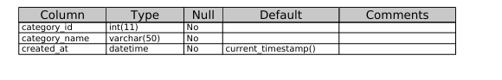
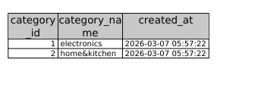

Product Table:
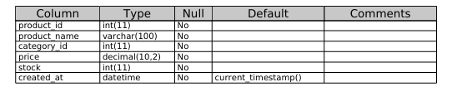
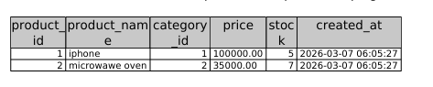
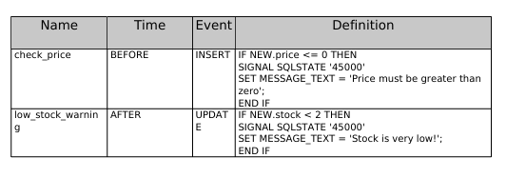
Order Table
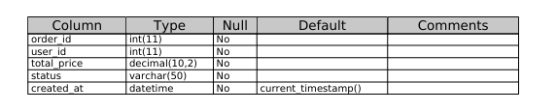
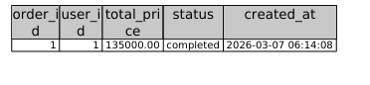
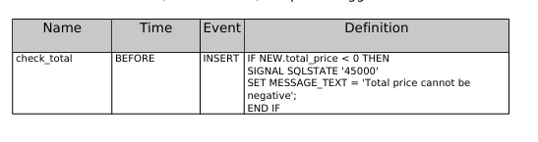
Order_Item Table:

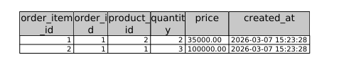
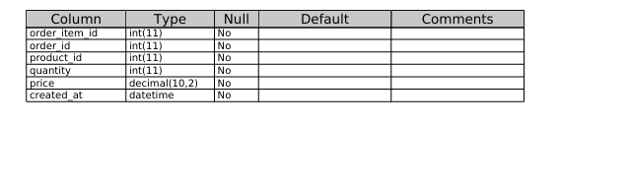
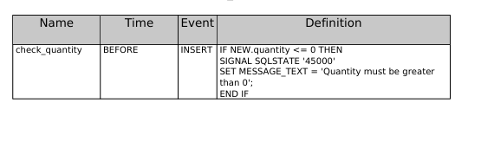
Key Connections

To link the tables properly, I established these foreign key relationships:
- User.role_id → Role.role_id (assigning roles to users)
- Product.category_id → Category.category_id (products tied to categories)
- Orders.user_id → User.user_id (users can place multiple orders)
- Order_Item.order_id → Orders.order_id (orders can contain multiple items)
- Order_Item.product_id → Product.product_id (items linked to products)

Visual Representation
(ER diagram showing the tables and their relationships)
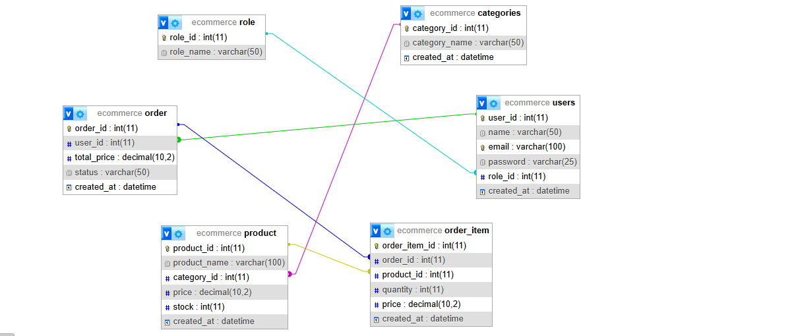
Insights from the Design
From this design, I understood that:
A user can place multiple orders
Each order can contain multiple products
Products are organized into categories
Roles help manage different types of users
Order_Item acts as a link between orders and products

Final Thoughts
This lab gave me practical exposure to how relational databases are applied in real-world systems like e-commerce. By using primary and foreign keys correctly, I was able to connect tables and maintain data integrity. It showed me how structured relationships make databases reliable and efficient

…………………………………………………………………………………………

